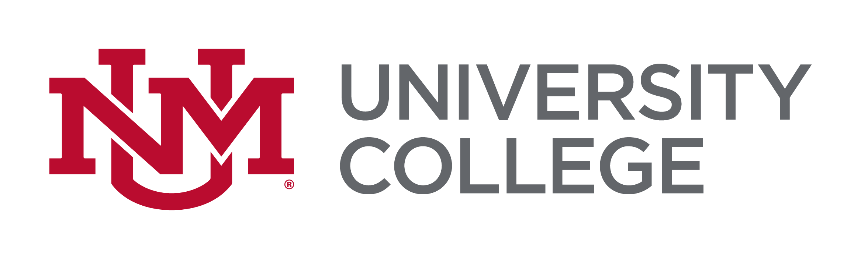

Native American Studies

The University of New Mexico – DEGREE PLAN
STUDENT NAME:
UNM ID:
COLLEGE: | University College
MAJOR: | Native American Studies, BA
CONCENTRATION:
MINOR:
EXPECTED GRADUATION DATE:
ADVISOR NAME: | Catherine N. Montoya
ADVISOR SIGNATURE:

COURSES TO BE COMPLETED

COURSE NUMBER | CREDIT HOURS | COURSE TITLE | SEMESTER
NATV 150 | 3 | Introduction to Native American Studies | Fall 2017

